Mire microclimate: groundwater buffers temperature in waterlogged versus dry soils

Short title: Testing the thermal buffer of mire groundwater

Eduardo Fernández-Pascual1 +, Eva Correia-Álvarez2

1 Universidad de Oviedo, 2 Independent researcher

+ Correspondence: Departamento de Biología de Organismos y Sistemas, Universidad de Oviedo, C/ Catedrático Rodrigo Uría, 33006 Oviedo/Uviéu, Spain. Email: [efernandezpascual@gmail.com](mailto:efernandezpascual@gmail.com). Telephone: +34985104787.

# Financial support

E.F.P. received financial support from the Government of Asturias and the FP7 – Marie Curie - COFUND programme of the European Commission (Grant ‘Clarín’ ACB17-19).

# Abstract

Ecosystems adapt differently to global warming through microclimate factors. Mires are sensitive wetland habitats that strongly rely on local soil properties, which makes them a good model to understand how local climate parameters counteract the effects of climate change. We quantifiedtested the hypothesis that temperature buffering effect in waterlogged mire soils as compared withare less variable and extreme than in adjacent dry soils.

We buried dataloggers at 5 cm depth in waterlogged and dry points in 8 mires of the Cantabrian Mountains (Spain, Southwestern Europe) and recorded soil temperatures for c. 5 years. We also compared our local measures with air temperatures predicted by the CHELSA model.

Waterlogged soils had less diurnal thermal amplitude (-2.3 ºC), less annual thermal amplitude (-5.1 ºC), cooler summer maximums (-4.3 ºC) and warmer winter minimums (+0.8 ºC). CHELSA airfailed to predict soil temperatures only correlated significantly (p < 0.05) with the winter minimum temperatures (Pearson’s r > 0.83), and CHELSA predictions were less accurate (higher RMSE) for waterlogged soils, except for the summer maximums in dry soils and the winter minimums in both dry and waterlogged soils.

We conclude that mire soils show a thermal buffer effect that insulates them from the surrounding landscape. This effect is stronger at the warm end of the climatic spectrum, i.e. during summer and at lower elevations. These results highlight the potential refugial character of mires under global warming, and the need to integrate microclimate measurements into climate change models.

# Keywords

bog, CHELSA, climatic model, datalogger, fen, peatland, soil temperature, wetland

# Introduction

Climate change (IPCC 2014) affects global biodiversity, from drylands (Huang et al. 2016) to forests (Seidl et al. 2017) and oceans (Hoegh-Guldberg et al. 2017). An accurate prediction of species responses requires to focus on physiologically relevant climatic variables related to critical plant growth periods (Gardner, Maclean, and Gaston 2019). Traditional models of species responses to global warming are based on macroclimatic data from weather stations. Recently, several authors have pointed out the need of complementing these models with *in situ* microclimatic measures (Lembrechts, Nijs, and Lenoir 2019; Lembrechts et al. 2019; Maclean, Mosedale, and Bennie 2019; Philippov and Yurchenko 2019). As has beenbeing shown for European forests (Zellweger et al. 2020), ecosystems usually respond to broad climatic changes through local processes. Increasingly there are downscaling efforts based on atmospheric microclimate networks distributed in complex terrain that focus on topographic effects on air temperature (Scherrer and Körner 2010), but hydrologic factors under edaphic control require more attention (Ashcroft and Gollan 2013An accurate prediction of species responses requires to focus on physiologically-relevant variables related to critical plant growth periods (Gardner, Maclean, and Gaston 2019).

Mires are permanent semi-terrestrial peatlands whose soils remain waterlogged but not inundated during most of the year (Wheeler and Proctor 2000). The term mire encompasses peatlands that are classified as either ombrotrophic (rain-fed bogs) or minerotrophic (groundwater-fed fens). TheseThey are azonal habitats whose existence depends on local soil properties rather than macroclimatic zonation (Breckle 2002). Groundwater adapted floras in spatially reduced areas (Grootjans et al. Worryingly, mires retain high levels of methane and carbon Habitat distribution models have predicted a loss of mire area as a consequence of ongoing climate change (Essl et al.

It has been known for a relatively long time that groundwater can produce a buffer effect on soil temperature, keeping soils warmer than air during cold periods, and vice versa (Frederick 1974; Ellenberg 1988; Geiger, Aron, and Todhunter 2009). Clara M. Frederick (1974) showedRoot-zone temperature is a major determinant of plant ecophysiology (Körner and Paulsen 2004), so the existence of a groundwater buffer effect comparing soilis expected to allow mire plants to live in a wider range of air temperatures taken at Cedar Bog (Ohio, United States) with temperaturesthan they could otherwise. Indeed, mires have a relatively homogeneous flora despite being distributed from Mediterranean to Boreal biomes, and from low valleys to the alpine belt (Peterka et al. a neighbouring agricultural station. Recently, more soil temperature measurements have become available for mires of North America (Patrick A Raney, Fridley, and Leopold 2014), Western Europe (Fernández-Pascual et al. 2015) and Central Europe (Horsák et al. 2018). Their comparison with air temperatures derived from models has shown that mire soils are indeed warmer in winter and cooler in summer, thus giving support to the existence of the groundwater thermal buffer (Fernández-Pascual et al. 2015; Horsák et al. 2018). Furthermore, the effect has been linked to the composition of mire flora and fauna (Horsák et al. 2018; Schenková et al. 2020), the growth rings of mire trees (Raney et al. 2016) and the role of mires as glacial refugia (Jiménez-Alfaro et al. 2016; Dítě et al. 2017).

-adapted floras in spatially-reduced areas (Grootjans et al. Worryingly, mires retain high levels of methane Habitat distribution models have predicted a loss of mire surface as a consequence of ongoing climate change (Essl et al.

Since root-zone temperature is a major determinant of plant ecophysiology (Körner and Paulsen 2004), the groundwater buffer effect is expected to allow mire plants to live in a wider range of air temperatures than they could otherwise. Indeed, mires have a relatively homogeneous flora across their range despite their broad distribution. In Europe, fens are distributed from the Iberian Peninsula to boreal Fennoscandia and from low valleys to the alpine belt (Peterka et al. In the arctic, temperate-continental and suboceanic regions of boreal Russia mires make up an important part of the landscape, from 20 to 80 % of the surface of different regions stretching from Europe to the Pacific (Yurkovskaya 2012). In the United States, fens are distributed across the glaciated Midwest and Northeast, as well as portions of the Appalachian Mountains and mountainous West (Bedford and Godwin 2003). However, continued aridification is expected to significantly reduce the overall extent of wetlands as it has been shown in the Midwestern United States (Johnson and Leopold 1994).

It is evident that the groundwater buffer effect will play a determinant role in the response of mire habitats to climate change (Patrick A. Raney 2014). Both bogs and fens are actively peat forming and are dependent on precipitation, whereas fens rely also on sources of telluric water from mineral ground. Moreover, they show a mosaic of microreliefs and a specific plant cover zonation which makes them especially sensitive to small changes in wetness. Climate change affects the quantity, timing and spatial distribution of precipitation, leading to changes in surface wetness which alter the intensity or organic decomposition by disturbing the conditions for plant grow and the depth of air penetration (Bragg 2002). Global warming would also result in warmer groundwater delivered to fens and in drier conditions, but there is a gap of knowledge about the rate of such changes and their ecological consequences within the mires (Patrick A. Raney 2014).

. As is the case for all azonal habitats, locally measured temperatures are essential to understand these processesthis response. Available references recorded temperatures only on waterlogged soils, using model-derived air temperatures for comparison (Fernández-Pascual et al. 2015; Horsák et al. 2018; Schenková et al. 2020); or recorded temperatures in both wet and dry spots but for less than a year, lacking representationrepresentativeness throughout the growth cycle of mire vegetation (Patrick A Raney, Fridley, and Leopold 2014; Raney et al. 2016). This article provides the first measurement of the thermal buffer against surrounding non-mire areas, based on soil temperatures recorded during a period of five years. These measures can be used to support previous evidence about the general effects of soil moisture on thermal buffering (Patrick A Raney, Fridley, and Leopold 2014; Fernández-Pascual et al. 2015; Horsák et al. 2018; Patrick A. Raney 2014) and to determine the magnitude of this buffering within microrefugia habitats. Specifically, we testedThese measures are used to test the hypotheses that, when compared to adjacent dry soils, waterlogged mire soil are (i) warmer in winter and (ii) colder in summer; and have less thermal amplitude in (iii) daily and (iv) annual scales. In addition, we comparedcompare *in situ* measurements with data derived from the CHELSA climatic models (Karger et al. 2017).

# Materials and methods

This study took place in the temperate oceanic region of north-western Spain (43º N, 5º W) (Fig. 1a). Local geography and climate are dominated by the Cantabrian Mountains (> 1500 m above sea level), which run parallel to the coast and trap the prevailing NW Atlantic winds. In the study area, average annual precipitation ranges from 800 mm at the low elevations to 1800 mm at the high mountains, while average annual temperature ranges from 12.5 ºC to 5 ºC (source = Agencia Estatal de Meteorología, <http://www.aemet.es/es/serviciosclimaticos/>). Under the most extreme emissions scenario, the latest projections expect temperatures to increase by 4 ºC and precipitation to decrease by c. 10 % by the end of the century, although the precipitation projections are subjected to great uncertainty (Amblar-Francés et al. 2017). The present humid and mild climate of this regionThe resulting humid climate harbours the south-western limit of mire communities in Europe (Jiménez-Alfaro, Díaz González, and Fernández-Pascual 2011; Fernández Prieto, Fernández Ordóñez, and Collado Prieto 1985). Rain-fed raised bogs (<https://eunis.eea.europa.eu/habitats/260>) are very rare and appear locally on raised hummocks of acid valley mires (<https://eunis.eea.europa.eu/habitats/526>) whichRain-fed raised bogs and acid valley mires can be found from the coast to just below the treeline, in poorly drained valleys and former glacial lakes. Glacial lakes undergoing silting develop transition mires and quaking bogs communities (<https://eunis.eea.europa.eu/habitats/1637>) in the water-to-land transition. Spring fens appear in the mountains above 1000 m; they range from soft-water poor fens (<https://eunis.eea.europa.eu/habitats/279>) on acid bedrocks, to alkaline calcareous fens (<https://eunis.eea.europa.eu/habitats/277>) on limestone.

We selected 8 mire sites representing the regional elevation gradient of mire vegetation and the different mire types (Table 1). Although we classify two of these sites as rain-fed bogs based on their vegetation (*Oxycocco-Sphagnetea* Br.-Bl. et Tx. ex Westhoff et al. 1946), we must note that these bogs are very poorly developed on hummocks over valley mires and are in tight connection to the underlying water table coming from streams. Therefore, soil waterlogging in all our sites is fed by streams or springs. In each site, we buried two dataloggers (M-Log5W, GeoPrecision, Ettlingen, Germany; accuracy: +/- 0.1 ºC (at 0 ºC), resolution: 0.01 ºC) at a depth of 5 cm below the upper layer of the soil. In this ecosystem, it is at this depth that true soil begins to develop, under the porous upper layers made up of live mosses. We installed: one datalogger in a flat waterlogged spot within the mire; the other one in the close vicinity, but in a flat and dry upland area outside the mire (Fig. 1b).. The vegetation at the sampling points was always either mire or pasture, with no shrubs, trees or any other landscape features shading the measuring points. Dataloggers recorded temperature once every houron an hourly basis and stayed on site for approximately five years, after which we retrieved them and downloaded their records. At the moment of retrieval, the internal clock of all dataloggers had not deviated for more than four hours.

All data processing and analysis was performed in R (R Core Team 2019). The original data, R code for the analysis and creation of the manuscript can be accessed at the GitHub repository <https://github.com/efernandezpascual/mires>. (The GitHub repository is private until publication, for peer-review a copy can be downloaded at <https://drive.google.com/file/d/1wnrNuQXvXcCruhKXdoFaRcm6tEZPaZkN/view?usp=sharing>) To clean the logs we took the following steps: (i) removing records from the first week after installation, to account for the installation process and the settling of the soils; and (ii) keeping only time series with records for both the dry and waterlogged points, because some of the dataloggers had failed at different points in time. Afterwards, we calculated four bioclimatic variables for each datalogger: (1) the mean diurnal range; i.e. the average for the whole period of the daily differences between the maximum and the minimum temperatures recorded in the day; (2) the maximum temperature of the warmest month; i.e. the average of the daily maximum records, for the warmest month; (3) the minimum temperature of the coldest month; i.e. the average of the daily minimum records, for the coldest month; and (4) the annual range; i.e. the difference between the maximum temperature of the warmest month and the minimum temperature of the coldest month. These are classical bioclimatic variables that indicate the limiting factors (extreme temperatures) and seasonality (diurnal and annual range) that organisms must tolerate (O’Donnell and Ignizio 2012). To compare our measurements with model-based predictions of air temperature, we downloaded from CHELSA the same bioclimatic variables for our measuring coordinates (<https://chelsa-climate.org/bioclim/>)..

To test if the differences between the dry and the waterlogged points wereof each site was significant, we used paired t-tests (n = 8 paired sites per each of the four bioclimatic variables).. Tests were one-tailed, according to the originalfollowing hypotheses: the dry point would have a higher diurnal range, a higher maximum temperature, a lower minimum temperature, and a higher annual range. To compare our soil measurements with the CHELSA air temperatures we calculated Pearson’s correlation between both sets of values, and we also calculated the root-mean-square error (RMSE) of the CHELSA values as a measure of their accuracy (n = 8 sites per combination of bioclimatic variable and dry/waterlogged condition). We calculated RMSE using its implementation in the package *Metrics* (Hamner and Frasco 2018).To test whether the CHELSA values predicted our measurements, we fitted linear models.

# Results

Dataloggers recorded temperatures for five years in five of the sites, four years in two, and two years in one. Time series showed considerably less variation at waterlogged points, for all eight site comparisons (Fig. 21).

Bioclimatic variables (Table 2 and Fig. 32) supported this notion. The mean annual range was wider at dry points, as was the mean diurnal range. Maximum temperatures of the warmest months were usually higher at dry measuring points. The opposite was true for the minimums of the coldest months, in which case temperature was generally colder at dry points, although the difference was less pronounced than for the maximums (Fig. 32).

Patterns regarding the maximum temperatures and annual range were especially noticeable at both low (El Molinucu, La Malva) and high (La Recoleta) elevations. The pattern for the diurnal range, however, was more prominent just at the low sites (El Molinucu, La Malva), whereas the minimums of the coldest months showed no specific pattern (Table 2).

T-tests supported the original hypotheses; namely waterlogged measuring points had (a) smaller diurnal fluctuations (t = -3.05, p = 0.009, effect size = -2.29 ºC, 95 % CI = -∞, -0.87); (b) lower maximums (t = -3.04, p = 0.009, effect size = -4.28 ºC, 95 % CI = -∞, -1.61); (c) higher minimums (t = 2.86, p = 0.012, effect size = 0.77 ºC, 95 % CI = 0.26, ∞),), and (d) smaller annual fluctuations (t = -3.95, p = 0.003, effect size = -5.05 ºC, 95 % CI = -∞, -2.63).

The CHELSA climatic model (Table 3 and Fig. 4) provided air temperatures that significantly correlated (p < 0.05) with soil temperatures only in the case of3) predicted well the minimums of the coldest month, bothespecially at dry points (Pearson’s rR2 = 0.90) and78) but also at waterlogged points (Pearson’s r = 0.84). The correlation betweenR2 = 0.66). CHELSA and soil values was marginally significant (p = 0.05) in the case ofalso predicted to some extent the maximums of the warmest month, but only at dry points (Pearson’s r = 0.71). The values ofR2 = 0.42), but failed to predict waterlogged points (R2 = 0.16). CHELSA did not correlate with soil temperatures in the rest of the cases (p > 0.05). RMSE indicated that the predictions of CHELSA were more accurate at dry points predict the values for the cases of the annual range, theand diurnal range, at both dry and the winter min; the CHELSA values were more accurate at waterlogged points in the case of the summer max.

# Discussion

The results presented here quantifyprove the sizeexistence of thea thermal buffer effect that takes place in waterlogged mire soils (Frederick 1974),, when compared with adjacent dry soils. The mire thermal buffer had been compared previously with air temperatures derived from models, with generally similar results (Fernández-Pascual et al. 2015; Horsák et al. 2018). The mire buffer had also been compared to dry soils at 10 cm depth (Patrick A but only during the growing season (Raney, Fridley, and Leopold 2014; Raney et al. 2016); our results confirm those findings at 5 cm depth and extend them to the full year. Also, in concordance with our results, the air temperature measured at 0.5 m from the surface of boreal Russian bogs is lower at the wetter zones, at least during the warmest months (Philippov and Yurchenko 2019). Thus, the pattern is reproducible among years (out to five years), seems to take place both at southern and northern latitudes, and may affect not only the temperature in the soil but also air temperatures withinTherefore, there exists a certain distance from the soil. The thermal buffer effect ofin mire soils that makes their temperatures less extreme than the surrounding landscape is therefore a general phenomenon. The existence of this buffer effect. This highlights the importance of using fine-scale microclimatic data to assess vegetation responses to climate change (Storlie et al. 2014; Lembrechts, Nijs, and Lenoir 2019; Zellweger et al. 2020).

One important difference with previous studies is the magnitudeimportance of the buffer during winter. The articles that had used model air temperatures as a control concluded that the buffer effect was stronger at the cold end of the thermal gradient, i.e. in winter and at night (Fernández-Pascual et al. 2015; Horsák et al. 2018). In the case of this investigation, the situation is thewas reverse: the effect iswas weaker when considering the minimum temperatures of the cold period. This indicates the importance of identifying root temperatures when working with plant communities. At high elevations of the study region, the soil can remain covered by snow for periods of winter, and this has its own insulating effect on soil temperatures (Körner 2003). Indeed, snow cover has being described as one of the vertical features that affects vegetation distribution in a local manner (Maclean, Mosedale, and Bennie 2019). In any case, since this study was conducted at the southern limit of mire distribution, more research on the winter buffer is needed at high latitudes, since it might have a deeper biological significance there.

In these southern miresconcordance with our results, the air temperature measured at 0.5 m from the surface of boreal bogs is lower at the wetter zones, at least during the warmest months (Philippov and Yurchenko 2019). Thus, the water buffering effect isseems to take place both at southern and northern latitudes and may affect not only the temperature in the soil but also the air temperature within certain highness from the soil. Nonetheless, Philippov *et al.* did not record winter months, so more monitoring is needed at more northern latitudes, where the winter effect may be more relevant (Horsák et al. 2018).

The buffering effect was much stronger during the summer (Fig. 5).. This iswas most noticeable in the two lowest elevations, El Molinucu and La Malva. La Malva shows especiallyshowed specially high summer temperatures within the dry soils (> 40 ºC). It must be noted that this difference of > 15ºC between the dry and waterlogged points of La Malva, which are separated by a few meters,This site is almost four times the warming expected in the study region at the end of this century (+ 4 ºC) under the more extreme emissions scenario (Amblar-Francés et al. 2017). Whereas the rest of the study sites are flat, La Malva is a calcareous spring in a southeast-facing slope on limestone, a place experiencing sub-Mediterranean conditions at the micro-scale (Sánchez de Dios, Benito-Garzón, and Sainz-Ollero 2009), and surrounded by a forest of evergreen oaks (*Quercus rotundifolia* Lam., *Quercus faginea* Lam.).). This suggests the importance of groundwater in the existence of mire vegetation in Mediterranean areas (De Hoyos et al. 1996), not only from the water-availability aspect, but also providing cooling regulation during summer (Ellenberg 1988). The buffering iswas also prominent at one of the highest elevations, La Recoleta, which may be explained by the high saturation of water in this kind of habitat, a quaking bog, i.e. a former glacial lake undergoing silting. However, the relatively small number of sites in our study does not allow to explore further the moderating factors that may drive differences in the strength of the buffer. More studies focusing on each kind of habitat are needed to understand the relation between hydrology conditions and microclimatic effects.

Most models currently employed to predict vegetation and species distribution use macroclimatic parameters, like the ones obtained from CHELSA (Karger et al. 2017). This study revealed that CHELSA values correlate relatively well with soil temperatures in the case of the minimum temperatures of the coldest month, but not with the rest of the bioclimatic variables under examination. Moreover, CHELSA predictions are less accurate for waterlogged soils, except for the summer max, which might be the consequence of the noise introduced by sun-heated soil. In addition to the water buffering effect, other features may explain the differences between our results and CHELSEA values, like the height of temperature measurement (5 cm below the upper layer of the soil in our study versus 2 m above the ground in CHELSA); the temporal scale of observation (hourly based for a 5 years period in our study versus a 34 years period); and the spatial resolution (c. 1 m in our study versus c. 1 km). Be that as it may, our results bring out the importance of consideringcan predict quite well the minimum temperatures at the coldest month in the mire habitats. However, it fails to predict temperatures at the warm extremes, especially at the waterlogged points. This brings out the importance of studying local factors as drivers of microclimatic changes (Zellweger et al. 2019). These factors contribute to landscape heterogeneity, producing safe sites that can act as micro-refugees and buffer species from regional climatic warming.

In summary, this article shows that waterlogged mire soils have a thermal buffer when compared to adjacent soils, contributing to their behaviour as mild island habitats in a landscape that can be more thermally variable (Patrick A. Raney 2014; Horsák et al. 2018). The effect occurs during cold and warm periods, but it is stronger during the summer, at least in the study area. However, this climatic buffering within microrefugia relies strongly on the water regime, a key factor for its conservation. Long-term decreases in precipitation could reduce the groundwater discharge into the mires, with potentially fatal consequences if the mires dry out during warmer summers. Rain-fed bogs will be affected more immediately than spring fens since the latter are somewhat decoupled from short-term rainfall variation. However, long-term regional drying would affect all types of mires. For the study area, the latest projections envision a decrease of c. 10 % in annual precipitation at the end of the century, but these projections are still subjected to a high level of uncertainty (Amblar-Francés et al. 2017). Future recording schemes are needed to monitor the evolution of the soil thermal buffer in drying regions,Future recording schemes are needed to obtain local soil temperatures from other latitudes, and from more microtopographies within the same mire. We must also consider that the microclimatic effect is not limited to mires as it can also be found in other habitats where a gradient of moisture exists (Ashcroft and Gollan 2013), such as the mosaic of microtopographies (snow patches, fellfields) that is characteristic of alpine environments (Scherrer and Körner 2010; Ohler, Lechleitner, and Junker 2020). ThisOur study provides useful microclimate parameters to improve the current models that predict the impact of global warming on moisture-drivenspecific ecosystems.

# Data availability

The original data, as well as the R code for the analysis and creation of the manuscript, can be accessed at the GitHub repository <https://github.com/efernandezpascual/mires>. Upon publication, a version of record of the repository will be deposited in Zenodo. (The GitHub repository is private until publication, for peer-review a copy can be downloaded at <https://drive.google.com/file/d/1wnrNuQXvXcCruhKXdoFaRcm6tEZPaZkN/view?usp=sharing>)

Upon publication, the original temperature records along with R analysis scripts will be uploaded to a public repository in GitHub.

# References

Amblar-Francés, P, MJ Casado-Calle, MA Pastor-Saavedra, P Ramos-Calzado, and E Rodríguez-Camino. 2017. *Guía de escenarios regionalizados de cambio climático sobre España a partir de los resultados del IPCC-AR5*. Madrid: Ministerio de Agricultura y Pesca, Alimentación y Medio Ambiente. Agencia Estatal de Meteorología.

Ashcroft, Michael B., and John R. Gollan. 2013. “Moisture, thermal inertia, and the spatial distributions of near-surface soil and air temperatures: understanding factors that promote microrefugia.” *Agricultural and Forest Meteorology* 176: 77–89. <https://doi.org/https://doi.org/10.1016/j.agrformet.2013.03.008>.

Bedford, Barbara L., and Kevin S. Godwin. 2003. “Fens of the United States: distribution, characteristics, and scientific connection versus legal isolation.” *Wetlands* 23 (3): 608–29. [https://doi.org/10.1672/0277-5212(2003)023[0608:FOTUSD]2.0.CO;2](https://doi.org/10.1672/0277-5212(2003)023%5B0608:FOTUSD%5D2.0.CO;2).

Bergamini, A., M. Peintinger, S. Fakheran, H. Moradi, B. Schmid, and J. Joshi. 2009. “Loss of habitat specialists despite conservation management in fen remnants 1995-2006.” Journal Article. *Perspectives in Plant Ecology, Evolution and Systematics* 11 (1): 65–79. <https://doi.org/10.1016/j.ppees.2008.10.001>.

Bragg, O. M. 2002. “Hydrology of peat-forming wetlands in Scotland.” *Science of the Total Environment* 294 (1-3): 111–29. <https://doi.org/10.1016/s0048-9697(02)00059-1>.

Breckle, Siegmar-Walter. 2002. *Walter’s Vegetation of the Earth: theThe Ecological Systems of the Geo-biosphere*. Book. Berlin - Heidelberg - New York: Springer.

Cornelissen, Johannes H. C., Peter M. Van Bodegom, Rien Aerts, Terry V. Callaghan, Richard S. P. Van Logtestijn, Juha Alatalo, F. Stuart Chapin, et al. 2007. “Global negative vegetation feedback to climate warming responses of leaf litter decomposition rates in cold biomes.” Journal Article. *Ecology Letters* 10 (7): 619–27. <https://doi.org/10.1111/j.1461-0248.2007.01051.x>.

De Hoyos, D

Dítě, Daniel, Tomáš Peterka, Zuzana Dítětová, Petra Hájková, and Michal Hájek. 2017. “Arcto-Alpine species at their niche margin: the Western Carpathian refugia of *Juncus castaneus* and *J. triglumis* in Slovakia.” Journal Article. *Annales Botanici Fennici* 54 (1–3): 67–82, 16. <https://doi.org/10.5735/085.054.0311>.

Ellenberg, Heinz. 1988. “Spring areas and adjacent swamps.” Book Section. In *Vegetation Ecology of Central Europe*, 313–13. Cambridge: Cambridge University Press.

Essl, Franz, Stefan Dullinger, Dietmar Moser, Wolfgang Rabitsch, and Ingrid Kleinbauer. 2012. “Vulnerability of mires under climate change: implications for nature conservation and climate change adaptation.” Journal Article. *Biodiversity and Conservation* 21: 655–69.

Fernández-Pascual, Eduardo, Borja Jiménez-Alfaro, Michal Hájek, Tomás E. Díaz, and Hugh W. Pritchard. 2015. “Soil thermal buffer and regeneration niche may favour calcareous fen resilience to climate change.” Journal Article. *Folia Geobotanica* 50 (4): 293–301. <https://doi.org/10.1007/s12224-015-9223-y>.

Fernández Prieto, José Antonio, María del Carmen Fernández Ordóñez, and Miguel Ángel Collado Prieto. 1985. “Datos sobre la vegetación de las turberas de esfagnos galaico-asturianas y orocantábricas.” Journal Article. *Lazaroa* 7: 443–71.

Frederick, Clara May. 1974. “A natural history study of the vascular flora of Cedar Bog, Champaign County, Ohio.” *The Ohio Journal of Science* 74 (2): 65–116.

Gardner, Alexandra S., Ilya M. D. Maclean, and Kevin J. Gaston. 2019. “Climatic predictors of species distributions neglect biophysiologically meaningful variables.” Journal Article. *Diversity and Distributions* 25 (8): 1318–33. <https://doi.org/10.1111/ddi.12939>.

Geiger, Rudolf, Robert H. Aron, and Paul Todhunter. 2009. *The Climate Near the Ground*. Book. Lanham: Rowman & Littlefield.

Grootjans, A. P., E. B. Adema, W. Bleuten, H. Joosten, M. Madaras, and M. Janáková. 2006. “Hydrological landscape settings of base-rich fen mires and fen meadows: an overview.” Journal Article. *Applied Vegetation Science* 9: 175–84. <http://search.ebscohost.com/login.aspx?direct=true&db=aph&AN=25691039&lang=es&site=ehost-live>.

Hamner, B, and M Frasco. 2018. “Metrics: Evaluation Metrics for Machine Learning. R package version 0.1.4. https://CRAN.R-project.org/package=Metrics.”

Hoegh-Guldberg, Ove, Elvira S. Poloczanska, William Skirving, and Sophie Dove. 2017. “Coral reef ecosystems under climate change and ocean acidification.” Journal Article. *Frontiers in Marine Science* 4 (158). <https://doi.org/10.3389/fmars.2017.00158>.

Horsák, Michal, Vendula Polášková, Marie Zhai, Jindřiška Bojková, Vít Syrovátka, Vanda Šorfová, Jana Schenková, Marek Polášek, Tomáš Peterka, and Michal Hájek. 2018. “Spring-fen habitat islands in a warming climate: partitioning the effects of mesoclimate air and water temperature on aquatic and terrestrial biota.” Journal Article. *Science of the Total Environment* 634: 355–65. <https://doi.org/https://doi.org/10.1016/j.scitotenv.2018.03.319>.

Hoyos, D deJournal Article.

Huang, Jianping, Haipeng Yu, Xiaodan Guan, Guoyin Wang, and Ruixia Guo. 2016. “Accelerated dryland expansion under climate change.” Journal Article. *Nature Climate Change* 6 (2): 166–71. <https://doi.org/10.1038/nclimate2837>.

IPCC. 2014. *Climate Change 2014: Synthesis Report. Contribution of Working Groups I, II and III to the Fifth Assessment Report of the Intergovernmental Panel on Climate Change [Core Writing Team, R.K. Pachauri and L.A. Meyer (eds.)]*. Book. Geneva: IPCC.

Jiménez-Alfaro, Borja, Tomás Díaz González, and Eduardo Fernández-Pascual. 2011. “Grupos de vegetación y hábitats de tremedales neutro-basófilos en las montañas pirenaico-cantábricas.” Journal Article. *Acta Botanica Barcinonensia* 53: 47–60.

Jiménez-Alfaro, Borja, Laura García-Calvo, Pedro García, and José Luis Acebes. 2016. “Anticipating extinctions of glacial relict populations in mountain refugia.” Journal Article. *Biological Conservation* 201: 243–51.

Johnson, Anne M., and Donald J. Leopold. 1994. “Vascular plant species richness and rarity across a minerotrophic gradient in wetlands of St. Lawrence County, New York, USA.” *Biodiversity and Conservation* 3 (7): 606–27. <https://doi.org/10.1007/BF00114204>.

Karger, Dirk Nikolaus, Olaf Conrad, Jürgen Böhner, Tobias Kawohl, Holger Kreft, Rodrigo Wilber Soria-Auza, Niklaus E. Zimmermann, H. Peter Linder, and Michael Kessler. 2017. “Climatologies at high resolution for the earth’s land surface areas.” Journal Article. *Scientific Data* 4 (1): 170122. <https://doi.org/10.1038/sdata.2017.122>.

Koffi, Ernest N., Peter Bergamaschi, Romain Alkama, and Alessandro Cescatti. 2020. “An observation-constrained assessment of the climate sensitivity and future trajectories of wetland methane emissions.” Journal Article. *Science Advances* 6 (15): eaay4444. <https://doi.org/10.1126/sciadv.aay4444>.

Körner, Christian. 2003. *Alpine Plant Life: Functional Plant Ecology of High Mountain Ecosystems*. Book. 2nd ed. Berlin - Heidelberg - New York: Springer.

Körner, Christian, and Jens Paulsen. 2004. “A world-wide study of high altitude treeline temperatures.” Journal Article. *Journal of Biogeography* 31: 713–32. [http://10.0.4.87/j.1365-2699.2003.01043.x http://search.ebscohost.com/login.aspx?direct=true&db=aph&AN=12823821&lang=es&site=ehost-live](http://10.0.4.87/j.1365-2699.2003.01043.x%0Ahttp://search.ebscohost.com/login.aspx?direct=true&db=aph&AN=12823821&lang=es&site=ehost-live).

Lembrechts, Jonas J., Jonathan Lenoir, Nina Roth, Tarek Hattab, Ann Milbau, Sylvia Haider, Loïc Pellissier, et al. 2019. “Comparing temperature data sources for use in species distribution models: from in-situ logging to remote sensing.” Journal Article. *Global Ecology and Biogeography* 28 (11): 1578–96. <https://doi.org/10.1111/geb.12974>.

Lembrechts, Jonas J., Ivan Nijs, and Jonathan Lenoir. 2019. “Incorporating microclimate into species distribution models.” Journal Article. *Ecography* 42 (7): 1267–79. <https://doi.org/10.1111/ecog.03947>.

Maclean, Ilya M. D., Jonathan R. Mosedale, and Jonathan J. Bennie. 2019. “Microclima: an R package for modelling meso- and microclimate.” Journal Article. *Methods in Ecology and Evolution* 10 (2): 280–90. <https://doi.org/10.1111/2041-210x.13093>.

O’Donnell, Michael S, and Drew A Ignizio. 2012. “Bioclimatic predictors for supporting ecological applications in the conterminous United States.” *US Geological Survey Data Series* 691 (10).

Ohler, Lisa-Maria, Martin Lechleitner, and Robert R. Junker. 2020. “Microclimatic effects on alpine plant communities and flower-visitor interactions.” *Scientific Reports* 10 (1): 1366. <https://doi.org/10.1038/s41598-020-58388-7>.

Pearson, Richard G., and Terence P. Dawson. 2005. “Long-distance plant dispersal and habitat fragmentation: identifying conservation targets for spatial landscape planning under climate change.” Journal Article. *Biological Conservation* 123 (3): 389–401. <https://doi.org/https://doi.org/10.1016/j.biocon.2004.12.006>.

Peterka, Tomáš, Michal Hájek, Martin Jiroušek, Borja Jiménez-Alfaro, Liene Aunina, Ariel Bergamini, Daniel Dítě, et al. 2017. “Formalized classification of European fen vegetation at the alliance level.” Journal Article. *Applied Vegetation Science* 20 (1): 124–42. <https://doi.org/10.1111/avsc.12271>.

Philippov, Dmitriy A., and Victoria V. Yurchenko. 2019. “Data on air temperature, relative humidity and dew point in a boreal *Sphagnum* bog and an upland site (Shichengskoe mire system, North-Western Russia).” Journal Article. *Data in Brief* 25: 104156. <https://doi.org/https://doi.org/10.1016/j.dib.2019.104156>.

Raney, Patrick A. 2014. *Identifying potential refugia from climate change in wetlands*. Syracuse, New York: Doctoral thesis, State University of New York.

Raney, Patrick A, Jason D Fridley, and Donald J Leopold. 2014. “Characterizing microclimate and plant community variation in wetlands.” Journal Article. *Wetlands* 34 (1): 43–53. <https://doi.org/10.1007/s13157-013-0481-2>.

Raney, Patrick A., Donald J. Leopold, Martin Dovčiak, and Colin M. Beier. 2016. “Hydrologic position mediates sensitivity of tree growth to climate: groundwater subsidies provide a thermal buffer effect in wetlands.” *Forest Ecology and Management* 379: 70–80recent climate change: wetlands as refugia in a warmer world.” Journal Article. *Ecological Applications* in press.

R Core Team. 2019. “R: a language and environment for statistical computing.” <https://www.r-project.org/>.

Sánchez de Dios, Rut, Marta Benito-Garzón, and Helios Sainz-Ollero. 2009. “Present and future extension of the Iberian submediterranean territories as determined from the distribution of marcescent oaks.” Journal Article. *Plant Ecology* 204 (2): 189–205. <https://doi.org/10.1007/s11258-009-9584-5>.

Schenková, Jana, Vendula Polášková, Martina Bílková, Jindřiška Bojková, Vít Syrovátka, Marek Polášek, and Michal Horsák. 2020. “Climatically induced temperature instability of groundwater-dependent habitats will suppress cold-adapted Clitellata species.” Journal Article. *International Review of Hydrobiology* 105: 85–93. <https://doi.org/10.1002/iroh.201902006>.

Scherrer, Daniel, and Christian Körner. 2010. “Infra-red thermometry of alpine landscapes challenges climatic warming projections.” *Global Change Biology* 16 (9): 2602–13. <https://doi.org/10.1111/j.1365-2486.2009.02122.x>.

Seidl, Rupert, Dominik Thom, Markus Kautz, Dario Martin-Benito, Mikko Peltoniemi, Giorgio Vacchiano, Jan Wild, et al. 2017. “Forest disturbances under climate change.” Journal Article. *Nature Climate Change* 7 (6): 395–402. <https://doi.org/10.1038/nclimate3303>.

Storlie, Collin, Andres Merino-Viteri, Ben Phillips, Jeremy VanDerWal, Justin Welbergen, and Stephen Williams. 2014. “Stepping inside the niche: microclimate data are critical for accurate assessment of species’ vulnerability to climate change.” Journal Article. *Biology Letters* 10 (9): 20140576. <https://doi.org/doi:10.1098/rsbl.2014.0576>.

Wheeler, B. D., and M. C. F. Proctor. 2000. “Ecological gradients, subdivisions and terminology of north-west European mires.” Journal Article. *Journal of Ecology* 88 (2): 187–203. <https://doi.org/10.1046/j.1365-2745.2000.00455.x>.

Yurkovskaya, Tatiana. 2012. “Mires on the map of Russia.” In *Mires from Pole to Pole*, edited by Tapio Lindholm and Raimo Heikkilä, 31–38. Helsinki: Finnish Environment Institute.

Zellweger, Florian, Pieter De Frenne, Jonathan Lenoir, Duccio Rocchini, and David Coomes. 2019. “Advances in microclimate ecology arising from remote sensing.” Journal Article. *Trends in Ecology & Evolution* 34 (4): 327–41. <https://doi.org/https://doi.org/10.1016/j.tree.2018.12.012>.

Zellweger, Florian, Pieter De Frenne, Jonathan Lenoir, Pieter Vangansbeke, Kris Verheyen, Markus Bernhardt-Römermann, Lander Baeten, et al. 2020. “Forest microclimate dynamics drive plant responses to warming.” Journal Article. *Science* 368 (6492): 772–75. <https://doi.org/10.1126/science.aba6880>.

# Tables

**Table 1**: Mire sites included in this study, indicating the type of fen, pH, conductivity,the elevation, coordinates, and length of the temperature recording period. Groundwater pH and conductivity values are the average of 5–10 measures per site taken with a MM40 Portable Multimeter (Crison Instruments S.A., Alella, Spain). Coordinates are in decimal degrees WGS84.

| Site | Habitat | pH | Conductivity (µS/cm) | Elevation (m) | Latitude | Longitude | Records (days) |
| --- | --- | --- | --- | --- | --- | --- | --- |
| El Molinucu | Raised bog | 4.2 | 47.2 | 284 | 43.3924 | -5.5392 | 1421 |
| La Malva | Alkaline fen | 8.2 | 427.7 | 700 | 43.1176 | -6.2543 | 1347 |
| La Vega Comeya | Raised bog | 5.9 | 102.4 | 822 | 43.2856 | -4.9885 | 664 |
| La Bruxa | Alkaline fen | 8.0 | 271.8 | 1528 | 43.0232 | -6.2113 | 1850 |
| La Veiga Cimera | Acid fen | 4.6 | 13.9 | 1552 | 43.0252 | -6.2539 | 1850 |
| La Recoleta | Quaking bog | 7.2 | 245.9 | 1768 | 43.0167 | -6.1112 | 1854 |
| El Riotuertu | Alkaline fen | 7.3 | 400.1 | 1820 | 43.0096 | -5.9479 | 1852 |
| La Vega Lliordes | Alkaline fen | 7.3 | 293.3 | 1878 | 43.1504 | -4.8464 | 1809 |

**Table 2**: Groundwater buffer effect per mire and bioclimatic variable. The buffer effect was calculated as the difference between the value in the waterlogged and the dry points.

| Site | Annual range | Diurnal range | Summer max | Winter min |
| --- | --- | --- | --- | --- |
| El Molinucu | -7.80 | -4.90 | -6.59 | 1.21 |
| La Malva | -10.81 | -5.14 | -10.25 | 0.56 |
| La Vega Comeya | -3.63 | -2.99 | -3.51 | 0.12 |
| La Bruxa | -1.09 | -0.88 | 0.99 | 2.08 |
| La Veiga Cimera | -3.41 | -2.21 | -3.47 | -0.06 |
| La Recoleta | -8.81 | -2.62 | -8.85 | -0.04 |
| El Riotuertu | -3.62 | 1.12 | -2.28 | 1.34 |
| La Vega Lliordes | -1.26 | -0.71 | -0.28 | 0.98 |

**Table 3**: Results of the linear models predicting the soil bioclimatic variables from the CHELSA air temperatures, per bioclimatic variable and groundwater situation. RMSE is the root-mean-square error, a measure of the accuracy of the predictions (lower values indicate higher accuracy).

| Variable | Groundwater | t | df | p | Pearson's rR2 | RMSE (ºC) |
| --- | --- | --- | --- | --- | --- | --- |
| Annual range | Dry | 0.012 | 6 | 0.991 | -0.0017 | 3.62 |
| Annual range | Waterlogged | -0.334 | 6 | 0.750 | -0.1415 | 4.71 |
| Diurnal range | Dry | 0.016 | 6 | 0.988 | -0.0117 | 3.09 |
| Diurnal range | Waterlogged | 1.354 | 6 | 0.225 | 0.4811 | 4.62 |
| Summer max | Dry | 2.450 | 6 | 0.050 | 0.7142 | 5.86 |
| Summer max | Waterlogged | 1.527 | 6 | 0.178 | 0.5316 | 2.95 |
| Winter min | Dry | 5.115 | 6 | 0.002 | 0.9078 | 4.04 |
| Winter min | Waterlogged | 3.809 | 6 | 0.009 | 0.8466 | 4.82 |

# Figures

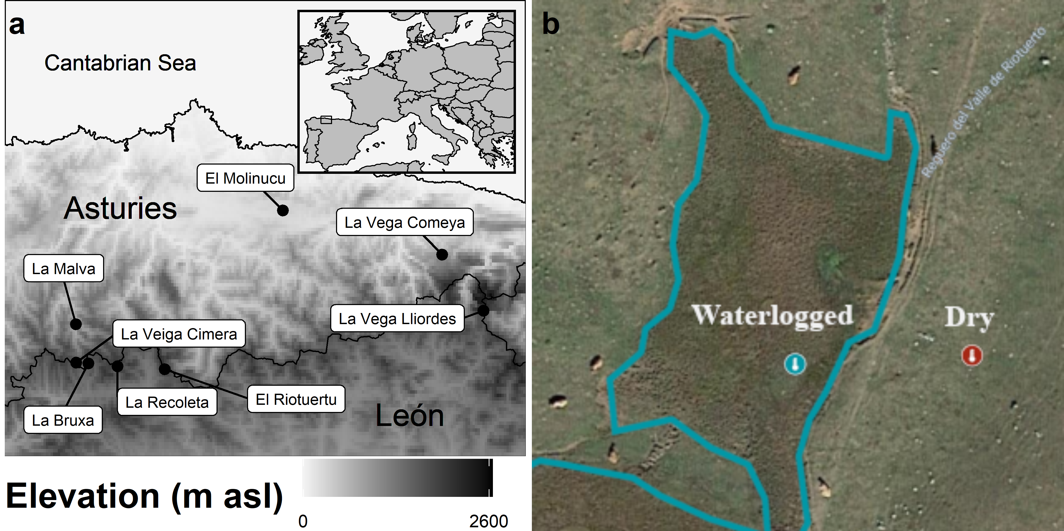

Figure 1: (a) Location of the study sites in northern Spain. (b) Representation of the sampling design at El Riotuertu site. The position of the dry and waterlogged temperature loggers is indicated, the blue area represents the extent of the waterlogged mire habitat.

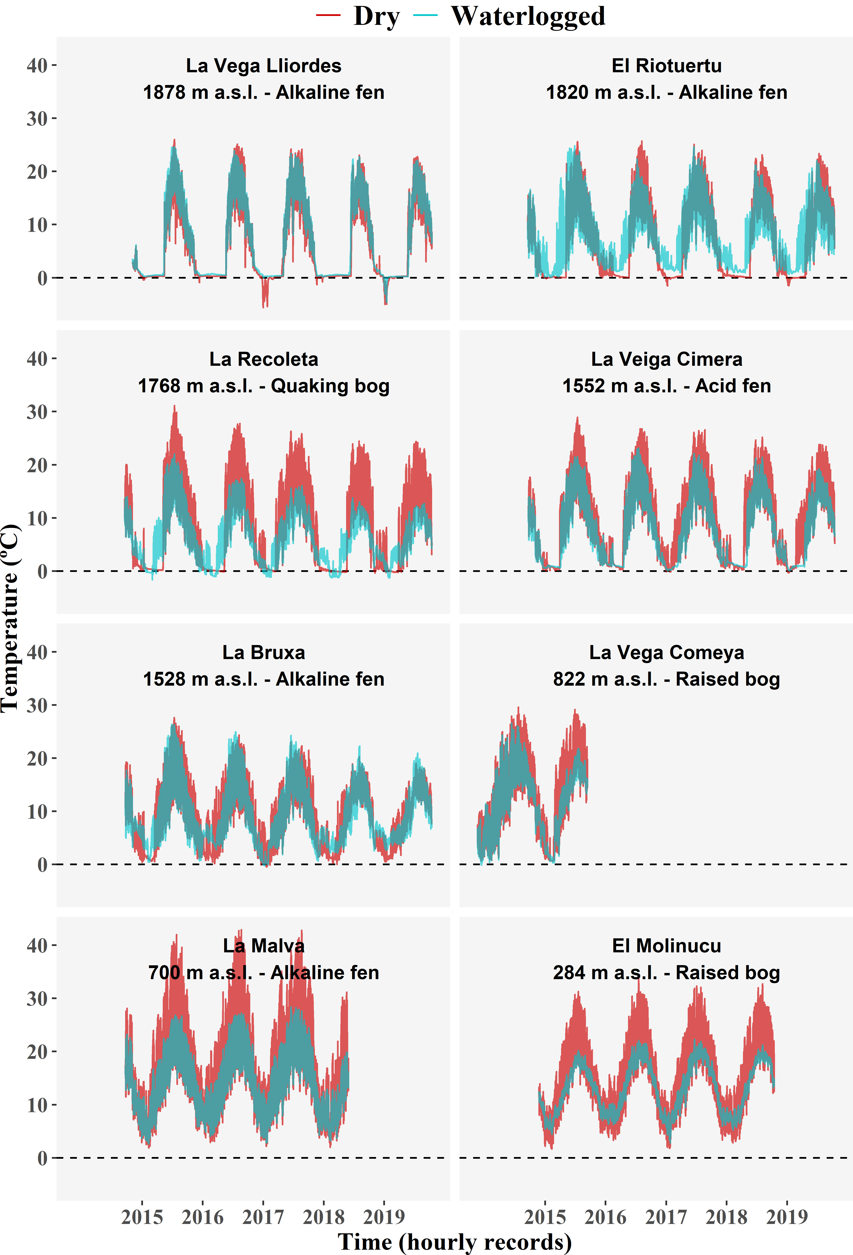

Figure 2: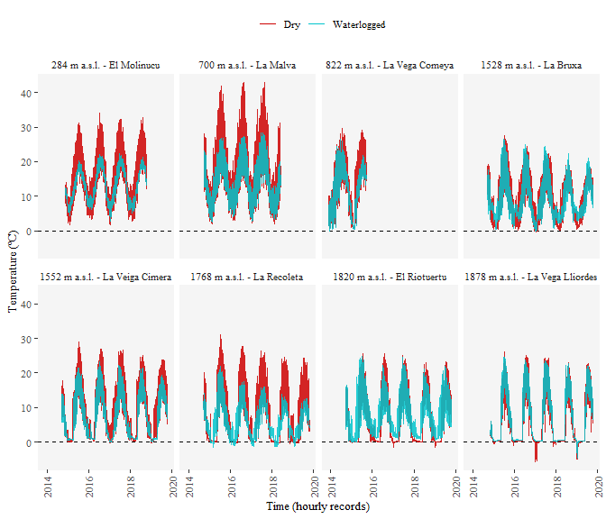

**Figure 1** Hourly soil temperature records at the mire sites. The blue series was recorded within the mire, in a waterlogged area. The red series was recorded in a neighbouring dry area. Dataloggers were buried at 5 cm depth. The amplitude of diurnal temperature range in dry sites was reduced with increasing elevation, where the thermal buffer effect was also less apparent.

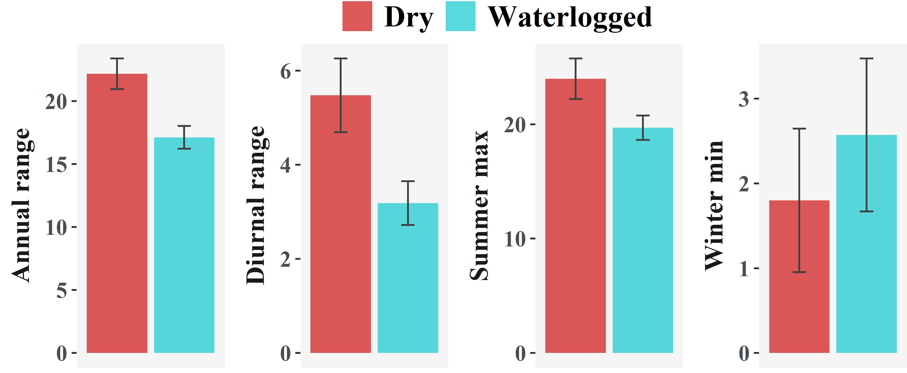

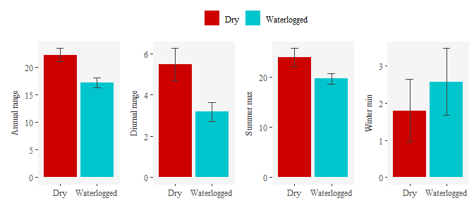

**Figure** 3:**2** Average bioclimatic variables in the dry and waterlogged points. The bars represent the mean value, and the brackets the standard error of 8 records.

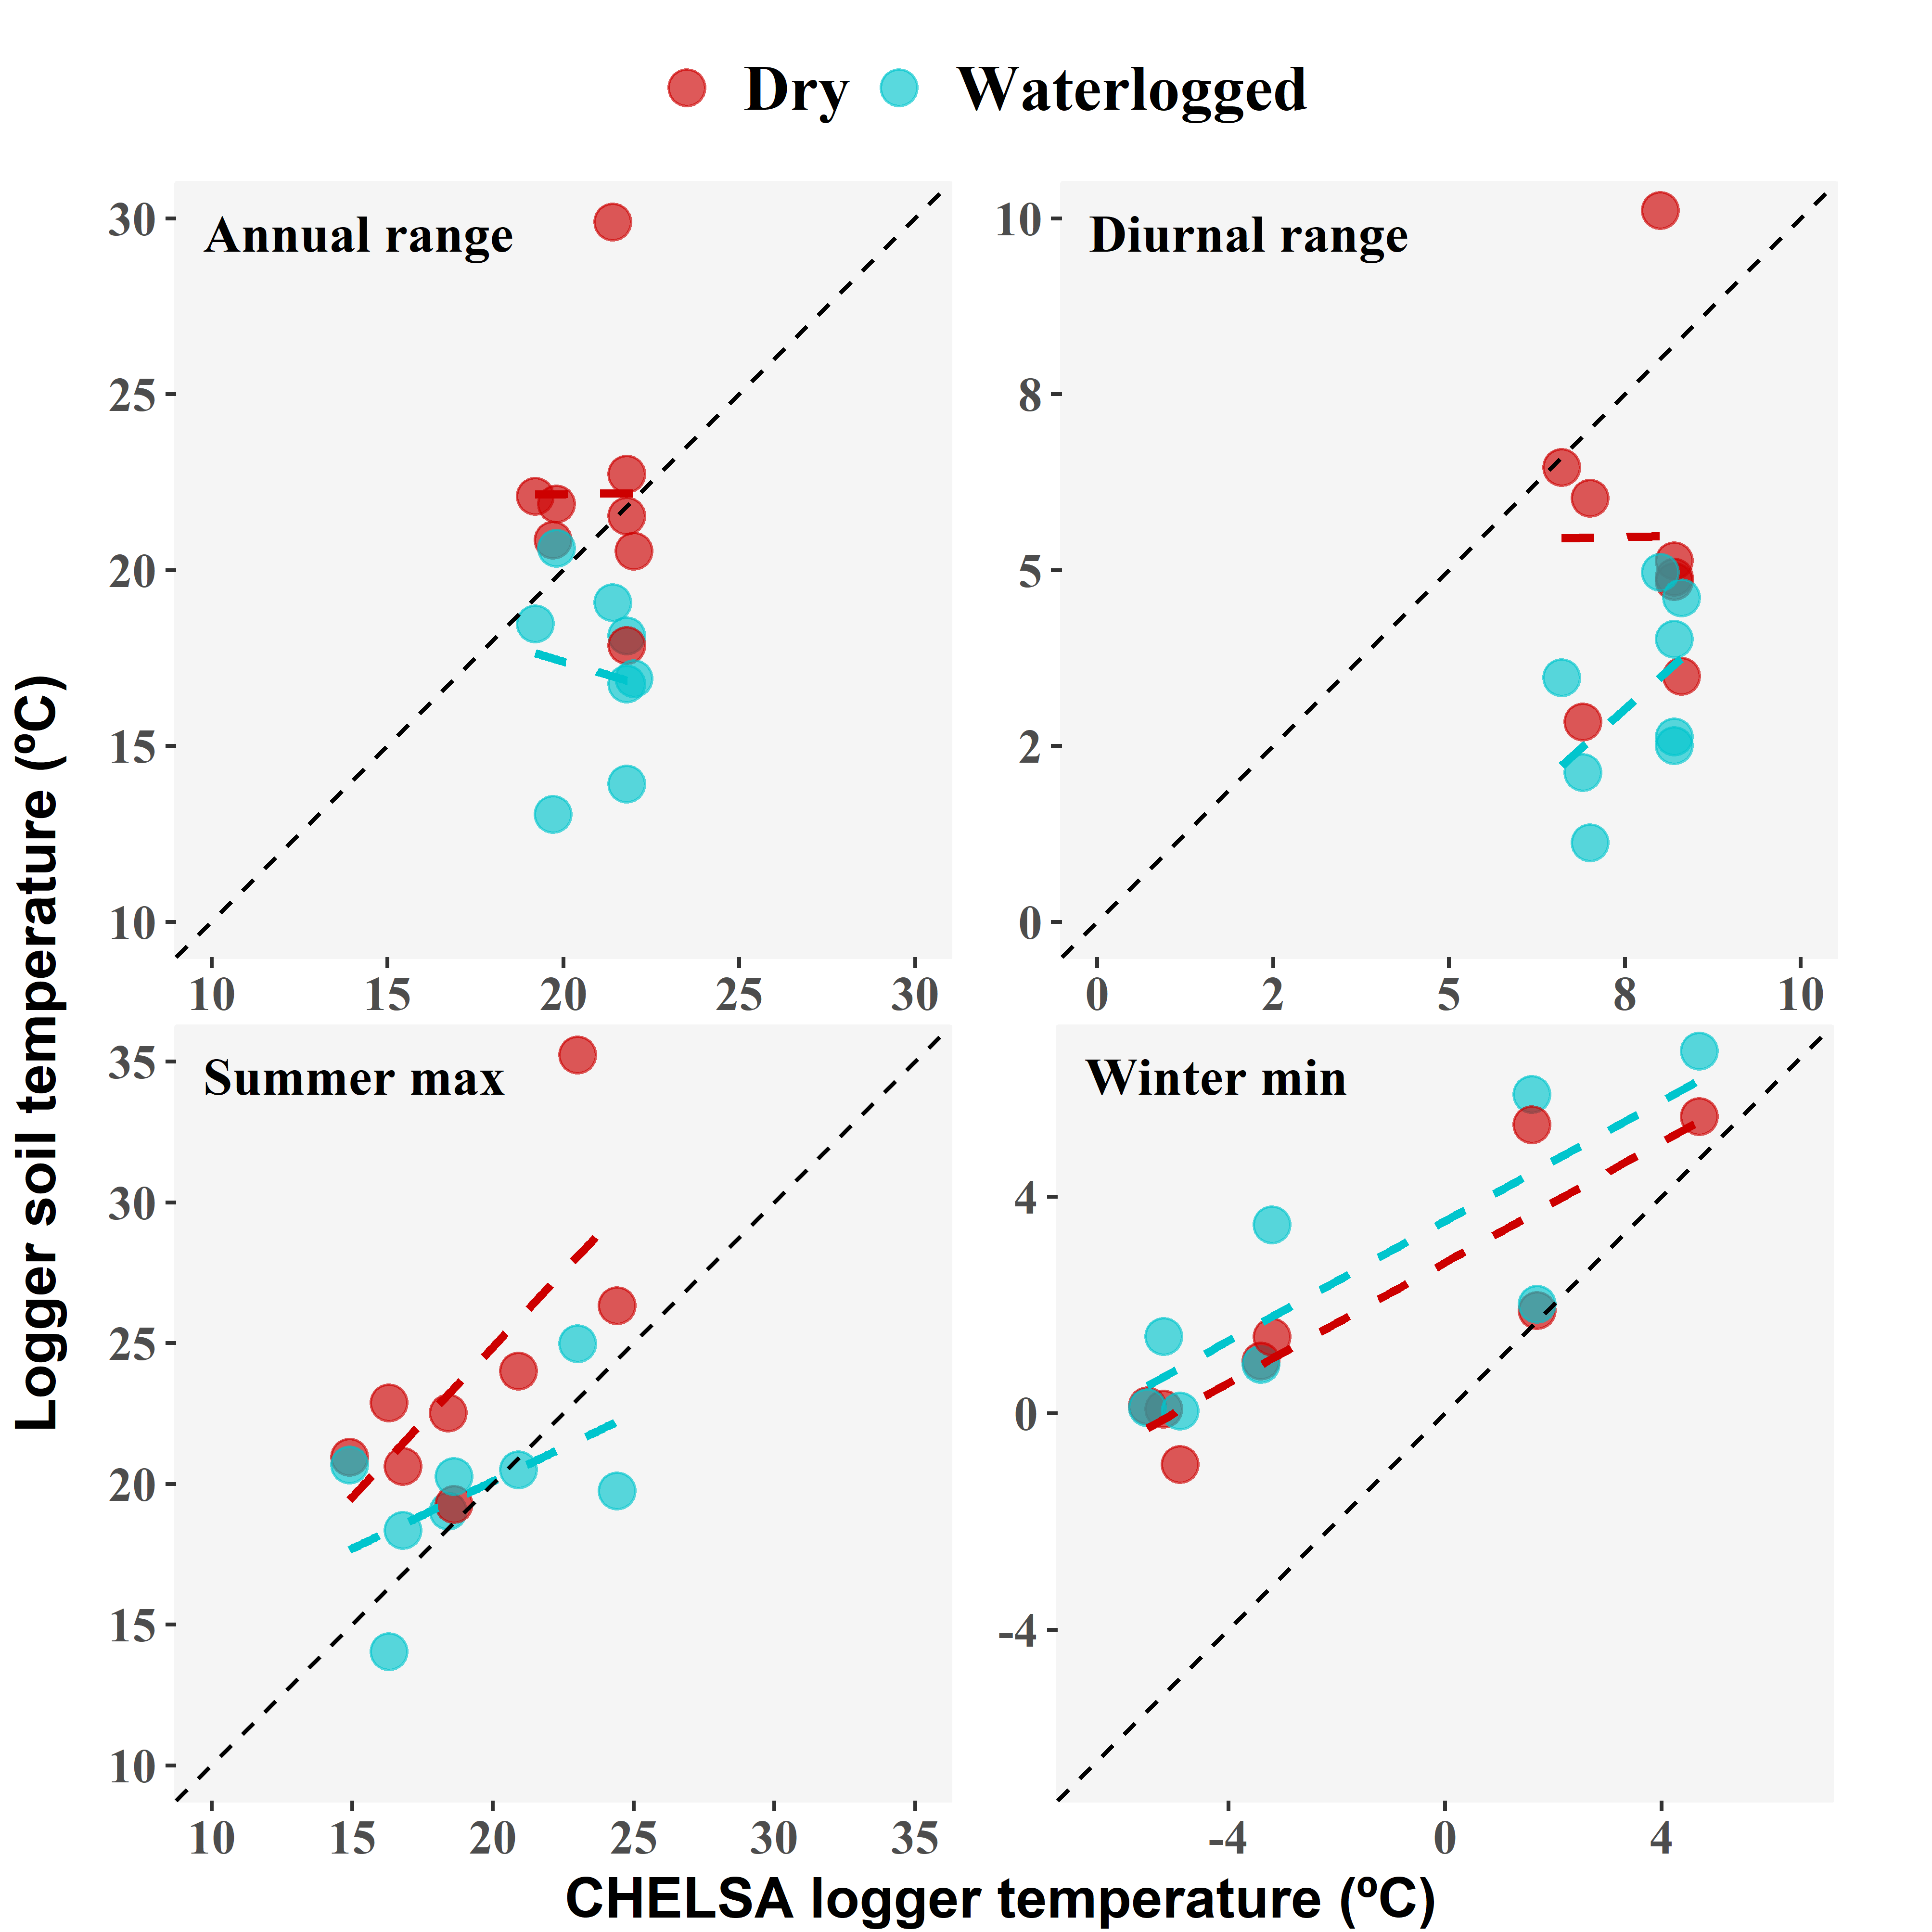

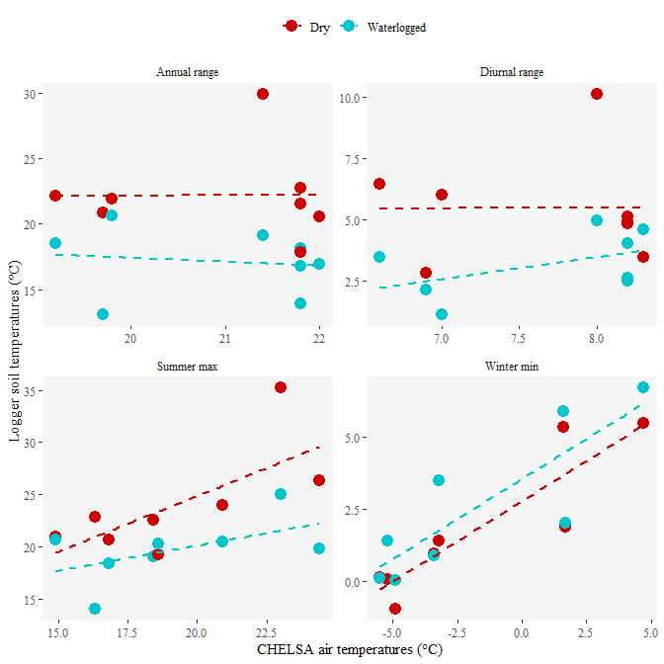

**Figure** 4:**3** Scatter plots of the bioclimatic variables predicted by CHELSA air temperatures vs. soil temperatures measured in situ, in dry and waterlogged points.

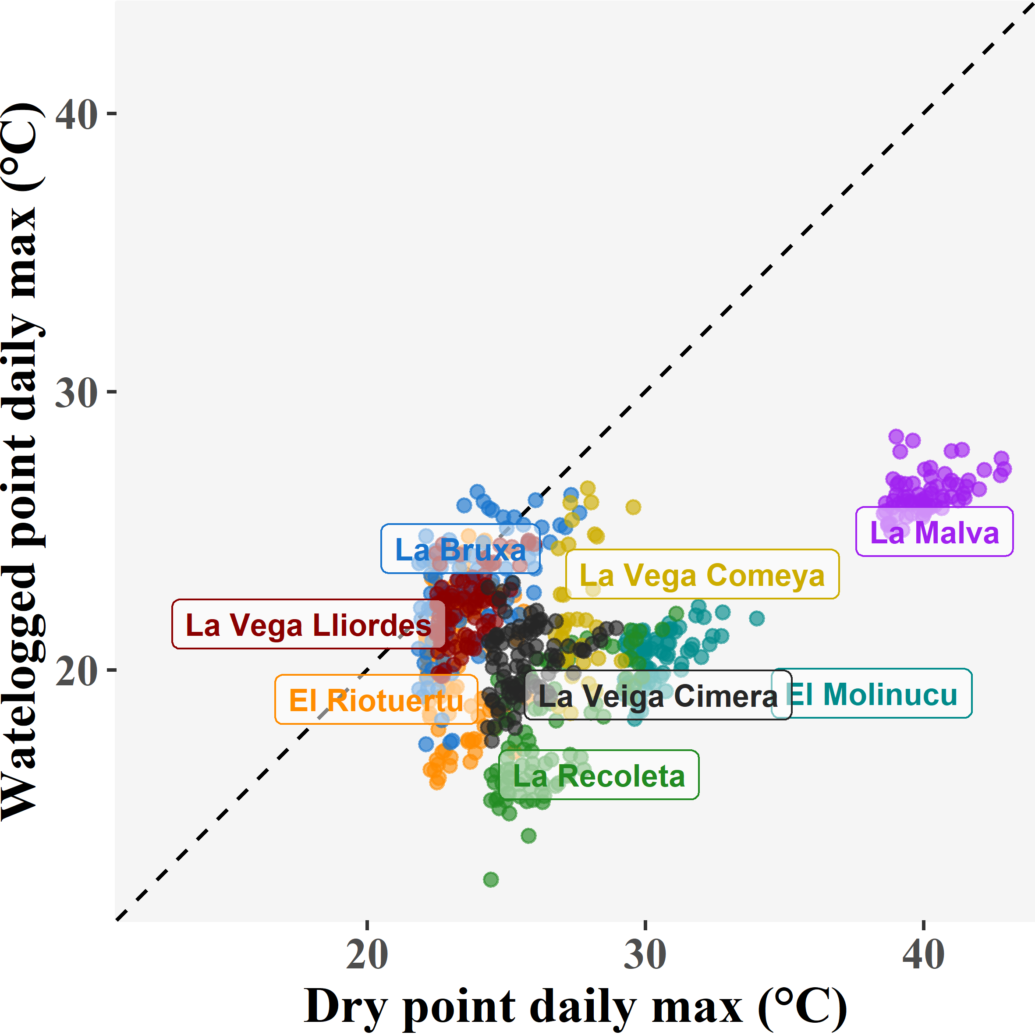

Figure 5: Complementary temporal analysis of the groundwater buffer effect during peak hot events. Variation of soil temperatures at paired sites (dry vs. waterlogged points) during exceptionally warm days of the warm season. Exceptionally warm days were considered those with a daily maximum (at the dry point) belonging to the 90th percentile of daily maximums for the site. The 1:1 line (corresponding to no buffer effect) is shown, points falling to the right of this line show a buffer effect (i.e. soil temperatures at the waterlogged point are cooler than the neighbouring dry site).